**LAB ASSIGNMENT 7.3**

**NAME:TAHIYA MAHEROZE**

**ROLLNO:2404A52349**

TASK1: Paste a function with a missing colon (add(a, b)), and let AI fix the syntax error.

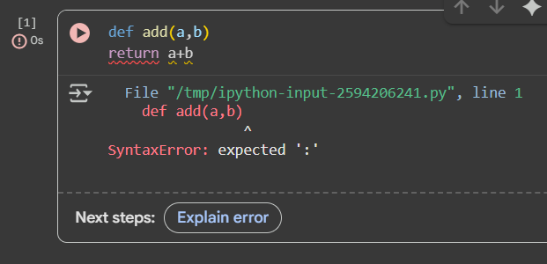

Corrected:

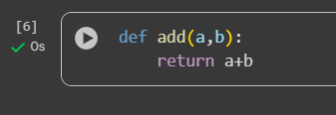

Explaination:

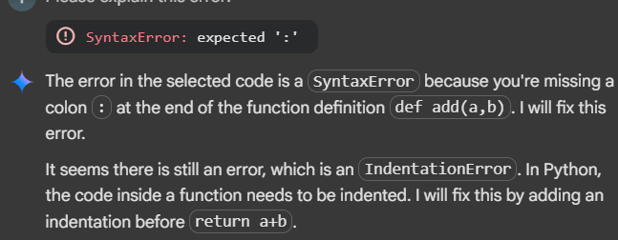

Task2: Identify and fix a logic error in a loop that causes infinite iteration.

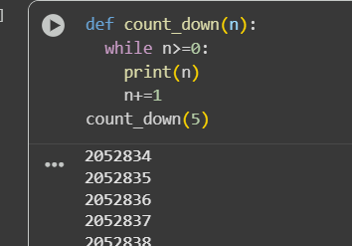

Corrected:

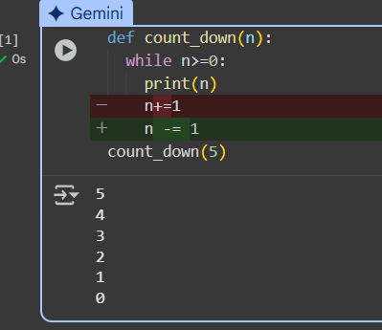

Explaination:

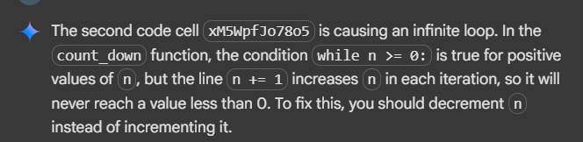

Task3: Debug a runtime error caused by division by zero. Let AI insert try-except.

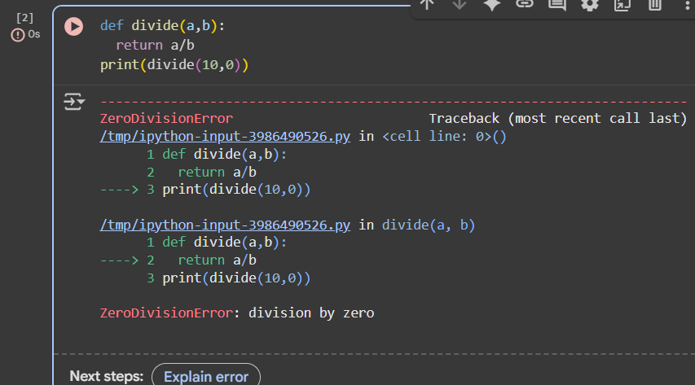

Corrected:

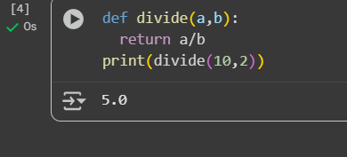

Explaination:

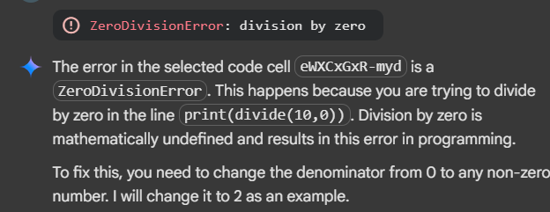

Task4: Provide a faulty class definition (missing self in parameters). Let AI fix it

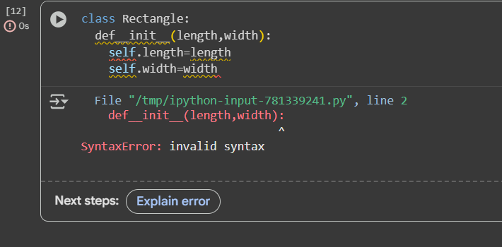

Corrected:

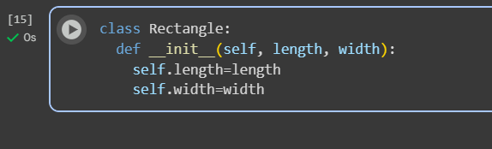

Explaination:

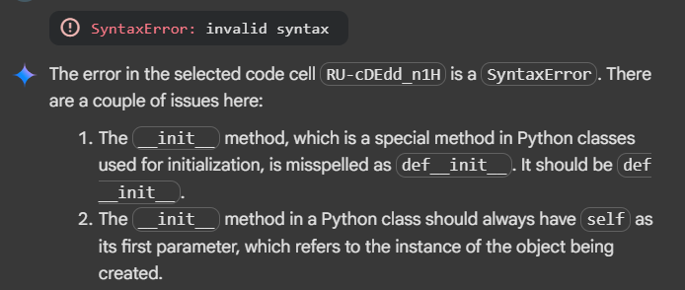

Task5: Access an invalid list index and use AI to resolve the Index Error

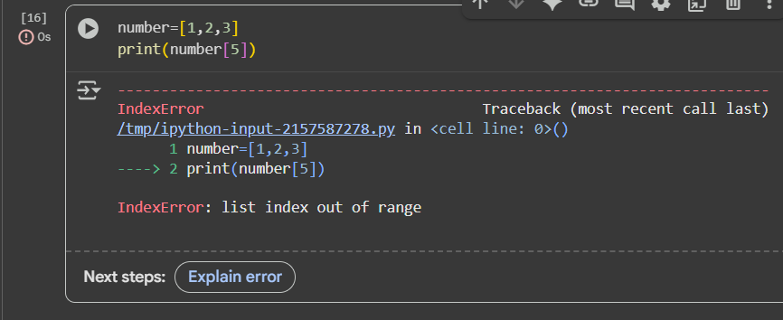

Corrected:

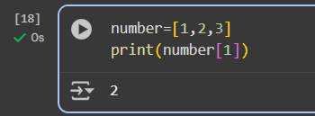

Explaination:

